TOPICS IN
POLITICAL SCIENCE

MONEY, MEDIA & MESSAGE:
Road to the White House ‘16

A comprehensive look at America’s
Political process in the digital age

Course ID # 15901F15

This course will look at all aspects of national campaigns, from the evolution of political parties and advertising, to the messages of potential ’16 candidates, the impact of social media and role of outside interest groups. The class will provide historical context in order to put current events into perspective, as well as lead lively classroom discussions & debates on the state of America’s political system.

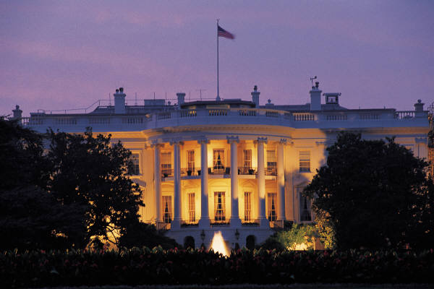

SYLLABUS
Fall Quarter 2015
September-December

Steven L. Scully
Adjunct Faculty, University of California DC

www.ucdc.edu

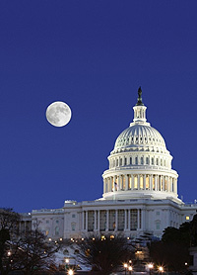

Welcome to the class!

Three things matter in any successful campaign:

- Message

- Money

- Organization

The right candidate, at the right moment in time, with the right message & campaign organization, usually wins. What will we see in the Road to ’16(00) Pennsylvania Avenue. We will examine and analyze the political, legislative and social issues facing our country, we will take an in-depth look at the events shaping the agenda for Congress & debate what impact they could have on the presidential race for each party. Our focus will also include the historical process of public policy making, as well as an intense examination on the changing role of media, especially social media, in shaping public opinion.

Course Goals

This course aims to introduce students to the academic study of American electoral politics by affording students the opportunity examine, analyze, discuss and debate the elements which make up a campaign, while also providing a strong historical perspective of past campaigns.

Student Learning Outcome Objectives

By the end of the course, students will:

Knowledge
- Understand key issues shaping the 2016 campaign
- Have a firm knowledge of the candidates, party structure, election rules, finance, messaging and organizations of political campaigns
- Understand how innovations in communications technology continuously change the dynamics of the American political process.
Skills
- Practice extensively the skill of formulating strategic questions.
- Research important aspects of the American electoral process.
- Analyze key issues- both arising within the campaign arena and shaping the political process.
Values
- Demonstrate an awareness of the principled differences among different actors and groups in the American political arena.
- Understand the challenges facing the civility of discourse in the American political campaign and public policy making processes.

Opportunity
- You are spending the quarter in Washington, D.C. This class and your internship experiences are designed to maximize your time in our nation’s capital. This class is designed to complement your DC experiences. Take advantage of what UCDC has to offer.

Contact Information:

NOTE:
We will meet every Thursday beginning at 6:30 pm for our regular classroom session.

Steven L. Scully is a former Associate Faculty member, The Washington Center for Internships and Academic Seminars & the Amos B. Hostetter, Jr. Chair in the School of Communications & Department of Political Science at the University of Denver & the Cable Center. Scully earned his undergraduate degree from The American University in Washington, D.C, completed a studies abroad program at The University of Copenhagen (Denmark) and earned a Master of Science from Northwestern University’s Medill School of Journalism in Evanston, Illinois. He began his teaching career at St. John Fisher College and Nazareth College in Rochester, N.H. and currently serves on the board of directors of the New Hampshire Institute of Politics. In addition, he is Senior Executive Producer & Political Editor for the C-SPAN Networks, as well as a regular on-air host for the “Washington Journal” & “Newsmakers” programs.

Phone: 202.626.7956
E-Mail address: SScully@C-SPAN.org
Mailing Address: 400 North Capitol Street, N.W.
Suite # 650
Washington, D.C. 20001

Office Hours: I will be available every Thursday following our evenings sessions and encourage you to see me if you have any questions regarding this course, scheduled assignments, or other projects. I can also schedule a time to meet with you any Friday morning, or you can call or e-mail during normal business hours to set up a conference call or a meeting at my C-SPAN offices (located on Capitol Hill) to discuss any concerns.

REQUIRED TEXTS:

Available at www.Amazon.com & Copies avail at UCDC

- MASS MEDIA & AMERICAN POLITICS (9th Edition) by Doris A. Graber & Johanna Dunaway

- THE GAMBLE: Choice & Chance in the 2012 Presidential Election
John Sides & Lynn Vavreck

SUGGESTED/ RECOMMENDED TEXT:

- COLLISION 2012: The Future of American Politics in a Divided America
Dan Balz

ALSO:

Select class handouts will be distributed during class (with an e-mail copy sent to you as well,) in advance of each class.

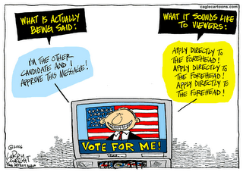

ADDITIONAL REQUIRED READING:

This class requires you to have a base knowledge of events occurring in and around the country and across the world.

You MUST keep up with current events in order to better understand the elements of the class, participate in our discussions, and have context to the issues presented in our lectures.

You MUST subscribe to two of the following four daily political blogs:

WWW.ABCNews.com (“The NOTE” Political Blog)

WWW.MSNBC.COM (“First Read” Daily Political Update)

WWW.CNN.COM (“Morning Grind”)

WWW.Politico.com (Mike Allen’s “Playbook”)

COURSE REQUIREMENTS:

Your final grade for the fall quarter will be based on your active participation, question preparation for each of the guests, exams, papers, weekly blog and other assignments.

1.) ATTENDANCE & CLASSROOM PARTICIPATION: 10 POINTS

It goes without saying that your attendance and participation is critical to the success of this class. You will only get out of this class what you put into it, so PLEASE come prepared, interact with our guests and your classmates, and debate the issues presented every Thursday. This course only works if you participate and actively engage in the topics. There will be occasional pop-quizzes in this class. Those scores will be included as part of your final grade.

Let me be very clear: Regular absences, late arrivals and/or early departures will affect your grade!

In order to let you know IN ADVANCE how I determine a grade for classroom participation, note the following:

A | You are in the class, ready to join the conversation with questions and comments, posing direct and ‘to the point’ questions to our guests and having a clear understanding of the weekly topics.
B | You have at least two unexcused absences and frequently participate in a thoughtful manner.
C | You have three or more unexcused absences and sometimes participate in classroom discussions
D | You have more than four unexcused absences and rarely participate.
F | You don’t show up and never participate.

2.) QUARTER EXAM 20 POINTS TOTAL

An single exam late in the quarter will consist of a series of short answer, multiple choice and a short essay questions based entirely on the required readings, class discussions and guests from this semester. You will be graded on the details and expertise you offer in your answers.

3.) ISSUE MEMO 10 POINTS

In a 2-3 page essay, outline the TEN THINGS you learned from either COLLISION 2012 by Dan Balz or The Gamble by Sides/ Vavreck. Begin your paper with a summary/ essay of the book and its main points. Then list the top ten things which you learned, which surprised you the most, from the book of your choice.

4.) SEMESTER RESEARCH REPORT 50 POINTS

7-9 page ESSAY:

AN ESSAY ON THE POLITICAL LANDSCAPE IN 2016: Lessons from 2008 & 2012 - Challenges for Democrats & Republicans in ‘16:

Based on your required reading, your final project this semester is to write an in-depth, thoughtful analysis on the current political climate:
- What challenges do the Democrats face as the party tries to secure Obama’s legacy by electing a Democrat?
- What lessons do the Republicans take away from its own presidential defeats in 2008 & 2012?
- Does the 2014 mid-term elections have an impact on 2016?
- What are the historical patterns for a president seeking re-election? (Identify the political, economic and foreign policy trends during the 2nd half of the 20th century & the first decade of this century.)

5.) STUDENT PRESENTATION 10 POINTS

At the start of the quarter, you will be assigned one candidate, one campaign to track particularly close. I will have the names in a hat for you to select in order to guarantee the class is tracking the most interest and competitive candidates, while also insuring we are following as many as possible. From time to time, I will be asking about your particular candidate during our Thursday sessions. And in our final class, you will each make a presentation to your fellow students, answering the following questions:
- What is your candidates’ strategy for winning?
- Has he/ she broken through in today’s diverse media environment?
- Take on the role of ‘campaign manager’ and outline what, if any changes you would make to the candidate and his/ her message?
- Can your candidate win the nomination?
- If so, what specific advice would you give the campaign in a general election campaign?

This is a RESEARCH AND ANALYSIS paper. Therefore, you must source your material. In addition to the required texts, you must provide at least five (5) additional outside sources. Then, summarize your research with an analysis summary that should be 2 -3 pages at the conclusion of your essay.

You will be graded on:
- Quality of your research
- Thoughtful writing
- Keen analysis

GRADING:

According to University of California policies, final course grades earned in this class will be worth the following points:
A = 4.0 A- =3.7 B+ = 3.3 B = 3.0 B - =2.7 C+ =2.3 C =2.0 C- =1.7 D =1.0 F =0.

WEEKLY SCHEDULE:

Each class will begin with a discussion on the readings, followed by a lecture topic & conclude w/ a Q & A session on relevant material. During select classes, I will bring in a guest to join us for a portion of the discussion. I will notify you in advance of those occasions and communicate with all of you via e-mail if there are changes or adjustments to the schedule.

Session 1: Thursday, October 1st
Course Introduction & Overview
Lecture Topic: 2008 Campaign – Lessons from Obama, McCain, Palin & Biden

Session 2: Thursday, October 8st

Readings – “Collision”: Pp. 3 – 158
Lecture Topic: Money in Politics

Session 3: Thursday, October 16th

Readings: “Collision”: Pp. 159-366
Lecture Topic: Developing the Strategy & Message

Session 4: Thursday, October 22nd

Readings: “The Gamble”: Chapters 1-3
Lecture Topic: Radio, Television & the Internet in Political Campaigns

Session 5: Thursday, October 29th

- Issue Memo Due Today
Lecture Topic: 1976 & 1980 Campaigns – Lessons from Carter, Ford & the Reagan Revolution

Session 6: Thursday, November 5th

Readings: “The Gamble”: Chapters 4-6
Lecture Topic: PAC’s, Special Interest & outside forces in American politics

Session 7: Thursday, November 12th

Readings: “The Gamble”: Chapters 7-8
Lecture Topic: 1992 Campaign – Lessons from Clinton & Bush

Session 8: Thursday, November 19th
Readings: “Mass Media & American Politics”
Part 1: Media Purpose & Structure
Chapters 1-4

Lecture Topic: 2000 Campaign – Lessons from Gore, Bush and the historic events shaping that election

- Semester Exam (during the 2nd half of today’s class)

NO CLASS – Thursday, November 26th – Happy Thanksgiving

Session 9: Thursday, December 3rd

Readings: “Mass Media & American Politics”
Part 2: Who & What Makes the News?
Chapters 5-8

Lecture Topic: Selling of the president & presidency: Advent of Madison Avenue in campaigns

Session 10: Thursday, December 10th
- Semester Research Paper Due Today
- Student Presentations on ’16 presidential campaign
Lecture Topic: Quarter Overview & Review

Readings: “Mass Media & American Politics”
Part 3: Media Effects, Current Trends and Future Directions
Chapters 10-13

ACADEMIC STANDARDS:

It goes without question, University of California has a high standard of academic excellence, and that includes students being honest in their research work. I have zero tolerance for plagiarism, recycled work and cheating. Please be advised that copying material that is not your own will result in automatic failure in this class. The web is a great tool, but it is also an easy tracking device for instructors to check out your material. And as always, cite your sources and use quotes when applicable in order to avoid even the appearance of impropriety. Please see also the TWC Course Policies at the end of this syllabus.

Disclaimer
Readings, assignments and due dates may be subject to change over the course of the semester. I will advise you of any changes and present them to you in writing.

Statement on Weather Emergencies
Although unlikely in the fall quarter, in the event of a weather emergency, UCDC follows the federal government’s decisions about delays and closures.

